## AUDIO SCRIPT FOR OPENING OF THRUST REVERSER (T/R)

***28/09 CCO REV1***

***Up date the timing with the animation***

*BY TRANSPARENCY PLEASE SHOWN THE A/C WITH SLATS RETRACTED AND FC OPEN*

***MSR : change the font picture of the global aircraft by the one with the fan cowl open***

***WRITTEN 1 ON A FIX IMAGE:***

YOU MUST RESPECT ALL WARNING AND CAUTION LISTED IN THE TASK OPENING THE THRUST REVERSER (T/R) COWL DOORS WITH POWER DOOR OPENING SYSTEM.

***MSR: to add in audio and text displayed***

***AUDIO 1 ON A FIX IMAGE:***

DO NOT APPLY LUBRICANT TO THE LATCHES, TO THE RECEIVERS, OR TO THE RELATED CABLES. THE LUBRICANT CAN CAUSE CONTAMINATION AND JAMMING OF THE LATCHES.

*THERE IS A MIXING BETWEEN THE 2 POINTS: WRITTEN THE FIRST ONE* ***AND*** *AUDIO FOR THE SECOND ONE! OR OPPOSITE BUT YOU MISS THE FIRST ONE*

***MSR : only audio without any text***

***AUDIO 2 ON IMAGE A/C WITH SLATS RETRACTED AND FAN COWLS OPEN:***

MAKE SURE WING SLATS ARE RETRACTED AND FAN COWL DOORS OPEN BEFORE YOU OPEN THRUST REVERSER (T/R) COWL DOORS.

THIS NOT THE GOOD AUDIO !!!????

***MSR : sound to put in accordance with the content of audio 2. Only audio***

***AUDIO 3 ON IMAGE COCKPIT WITH LOCKING TOOL INSTALLED:***

MAKE SURE THE LOCKING TOOL IS INSTALLED ON THE SLAT/FLAP CONTROL LEVER BEFORE YOU OPEN THE THRUST REVERSER (T/R) COWL DOORS.

AGAIN YOUR TAKING ABOUT FAN COWL DOOR NOT THE GOOD AUDIO!!!!???

***MSR : sound to put in accordance with the content of audio 3. T/R instead of FC.***

***AUDIO 4 ON IMAGE COCKPIT WITH C/B PULLED:***

OPEN, SAFETY, LOCK AND TAG THE CIRCUITS BREAKERS LISTED ON THE TASK AND DISPLAYED ON THE ECAM PAGE.

LET S THIS CORRECTED AUDIO AS IT IS DONE FOR FAN COWLS

***MSR : keep the sound with “Make sure that …”***

***AUDIO 5 – TC 00:07:***

Open the Thrust Reverser Latch access-doors FWD fully and AFT

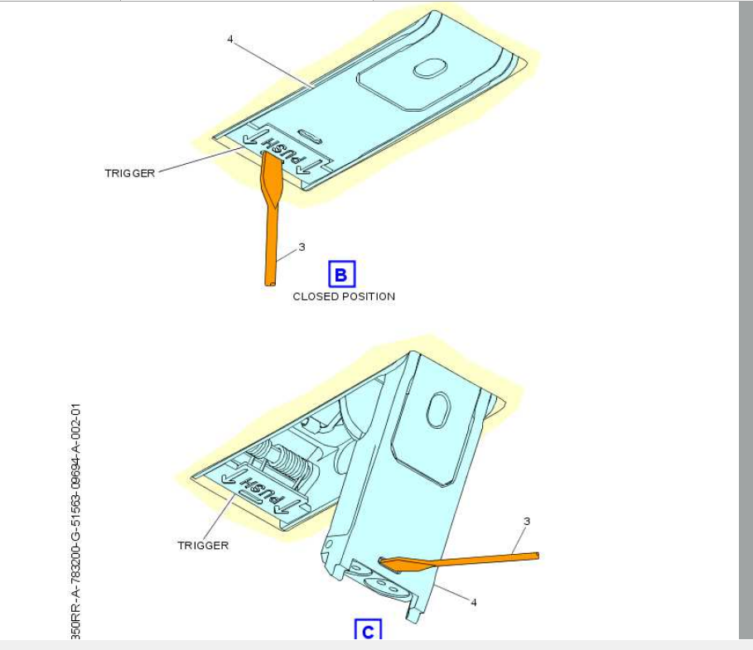

GOOD ANIMATION BUT DEPLACE THE CAMERA TO SEE THE SLIDING OF THE SMALL PART (TRIGGER) OF THE LATCH

***MSR : cam02 ok***

***AUDIO 6 – TC 00:37:***

To open the T/R cowl latches in the sequence: latch L6 latch, L3 latch, L5 latch, CAD STOP 2SECONDS MAKE 2 TURNS SLOWLY THE BARRE TO SHOW THE PULLING OF THE 2 TR , L2 latch, L1 latch DO NOT REPLACE THE PIN WHEN THE LEVER IS PULLED, ONLY AT THE END OF L1 DEPLACEMENT, L4 latch and CAD STOW.

This latching sequence is written inside the access doors.

***MSR : reworked sounds:***

***To open the T/R cowl latches in the sequence: latch L6, L3, L5, CAD***

***Pause of 2 seconds and make slowly turns the barre 2 times to show the pulling of the 2 TR side. (amber text not to add in the sound)***

***L2, L1***

***DO NOT REPLACE THE PIN WHEN THE LEVER IS PULLED, ONLY AT THE END OF L1 DEPLACEMENT,***

***L4 and CAD STOW. This latching sequence is written inside the access doors.***

***NOTE: Use the Closure Assist Device (CAD) to pull the T/R cowls together, pull it from the stow clip. Hold the free end of the CAD and turn the barre, to increase the length and to Make sure that approximately an equal amount of thread on each side of the CAD.***

***AUDIO 7 – TC 00:30:***

Make sure that all of the latches are open and that the hooks are disengaged from the keepers before you open the T/R cowls.

***AUDIO 8 – TC 00:41:***

Locate the PDOS buttons on the side of each inlet cowl.

***AUDIO 9 – TC 00:37:***

Press the PDOS “UP” switch to move the T / R cowl a few degrees more than the full open position (45 degrees).

THE LOCKING SYSTEME OF THE HOR OF THE FAN COWL HAS TO BE GREEN NOT RED **(done)**

***AUDIO 8 – TC 00:37:***

Before to reach the full opening, Deploy the Hold Open Rod ~~(~~H O R~~)~~ and put it in place ~~.~~

Continue to open to the fully open position and you can see the green locked indicator on the HOR

***AUDIO 9 – TC 00:41:***

Push the PDOS ‘Down’ switch until the weight of the T/R cowl is on the HOR. The HOR is not locked safely unless you can see the green locked indicator